Ideation Phase

Empathize & Discover

|  |  |
| --- | --- |
| Date | 26 june 2025 |
| Team ID | Single |
| Project Name | Freelance application mern |
| Maximum Marks | 4 Marks |

Freelancer Empathy Map

1. FEELS

* Frustrated by ghosting clients and payment delays
* Anxious about inconsistent income
* Undervalued when competing with low-cost bids
* Isolated working alone without community support

2. DOES

* Spams applications to increase chances ("Spray & Pray")
* Lowers rates to win projects (undercutting)
* Uses 3+ platforms simultaneously (fragmented workflow)
* Chases payments instead of focusing on creative work

3.PAINS

* ➔ Unpredictable income (Feast-or-famine cycle)  
  ➔ No portfolio visibility (Great work gets buried)  
  ➔ High platform fees (20-30% commissions)  
  ➔ Misaligned projects (Clients don’t understand scope)

4.GAINS

✓ Fair pricing (Skills-based matching, not bid wars)  
✓ Portfolio spotlight (Interactive project showcases)  
✓ Payment protection (Escrow and milestone payments)  
✓ Community hubs (Networking with peers/clients)

Demo idea imagination;

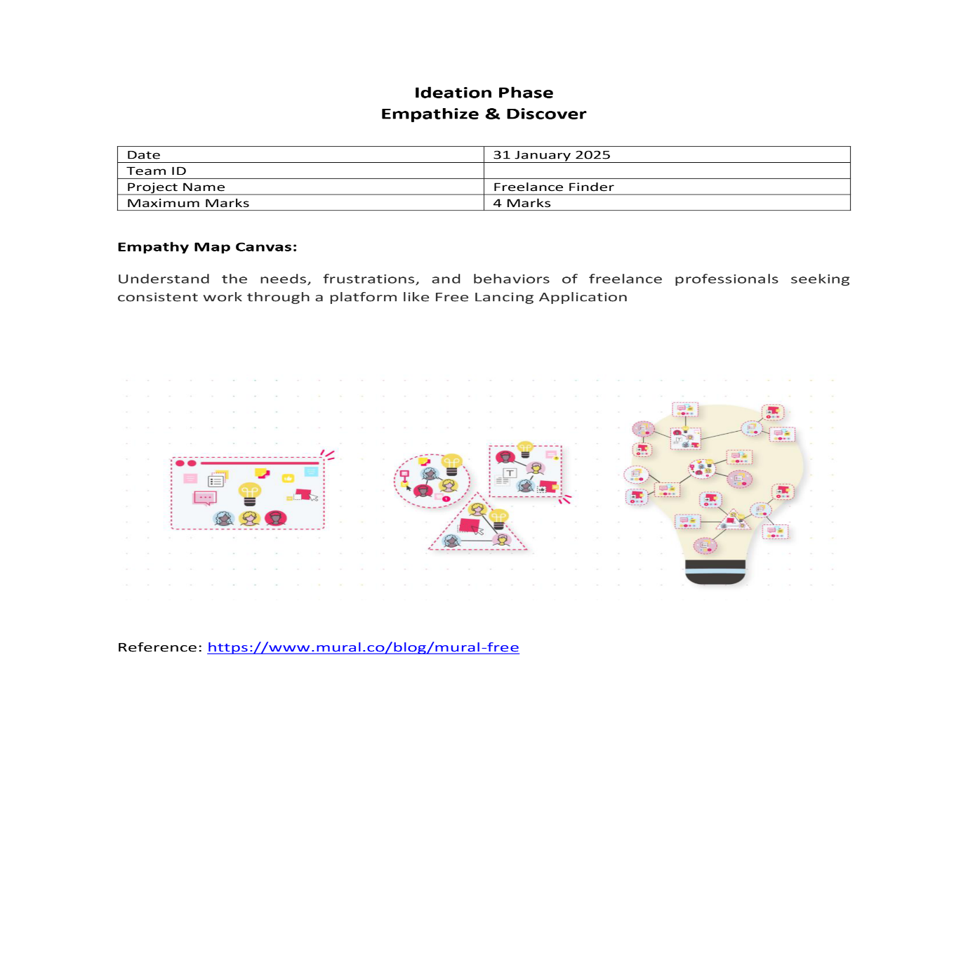

Reference: <https://www.youtube.com/watch?v=7CqJlxBYj-M>